Notio Technologies Inc. is the technological subsidiary of the Argon 18 bike manufacturer. A number of cyclists participated in the development of the revolutionary Notio Konect product and were the first to experiment with their analytical capabilities before finding themselves on the track, the triathlons or on the circuit of the Tour de France

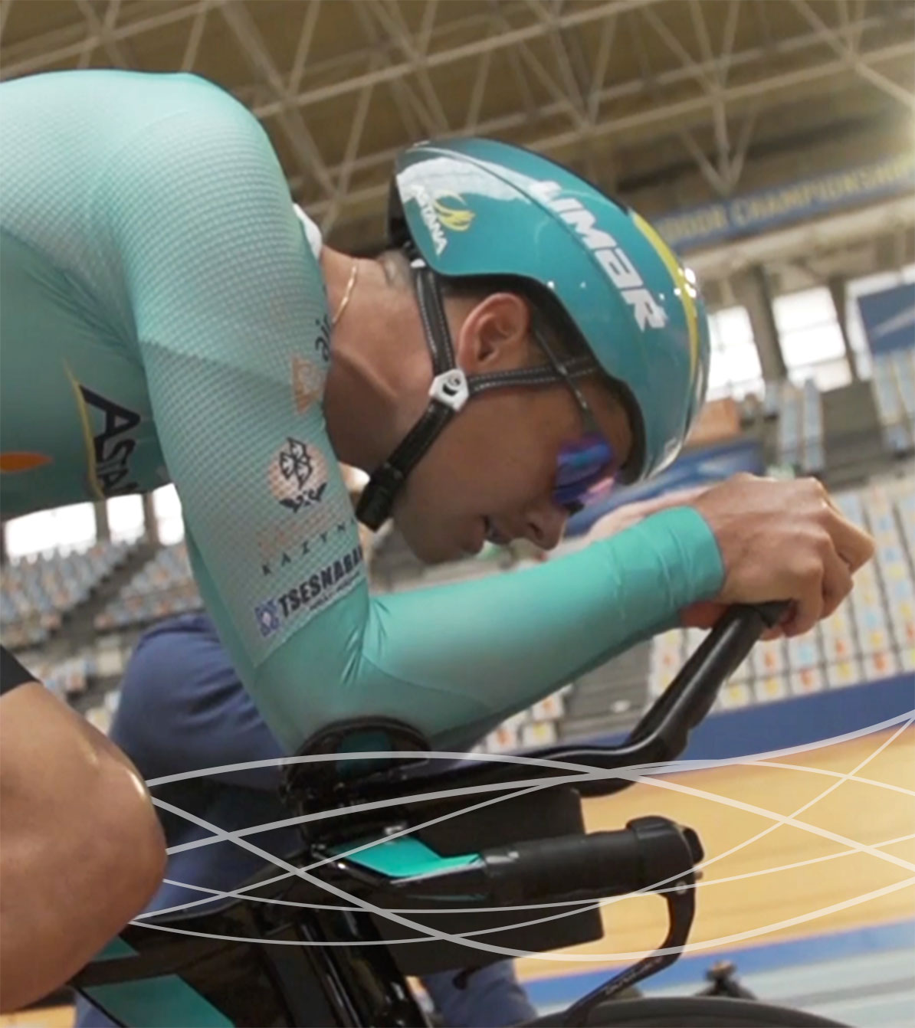
Our team is made up of dynamic and passionate professionals, always ready to face new challenges. We are currently looking for a bike enthusiast who is motivated, skilled and technologically skilled to fill the next position:

SPECIALIST - PRODUCT SUPPORT
2017-033

SPECIFIC RESPONSIBILITIES
Product testing
- Will participate in in house (lab) testing as well a field testing.
Product support
- Will assist customers and resellers with the installation, configuration and troubleshooting of the product

Product Education
- Will teach resellers on the proper use of the product

REQUIRED QUALIFICATIONS AND ATTRIBUTES

- Requires good interpersonal and communication skills;
- Ideally the person should have a good science background ;
- The person must communicate effectively in English;
- The person must be prepared to multi-task in a constantly changing environments;
- Knowledge of cycling with basic principles of riding with power, aerodynamics, fitting and training good trouble shooting skills and technical ability (computers, mobiles, power meters, Garmins);
- An experienced rider is preferred.

TO APPLY

Our team is composed of dynamic and passionate professionals who are always ready to face new challenges.
Qualified candidates, please email cover letter, résumé and portfolio of work to:
cv@innovationrh.com

Only selected candidates will be contacted.

